Specular Texture

📘 Definition
# Source: AI Source: Provided by: [Data Path: Persons Table -> ID Column: 1, Name_En Column: Motasem Essam] -> From: [ChatGPT] on [5/2/2026]
A Specular Texture is a texture that controls how shiny different parts of a 3D surface are. It defines where light will create bright reflections (highlights) on an object.

💡 How specular texture works
# Source: AI Source: Provided by: [Data Path: Persons Table -> ID Column: 1, Name_En Column: Motasem Essam] -> From: [ChatGPT] on [5/2/2026]
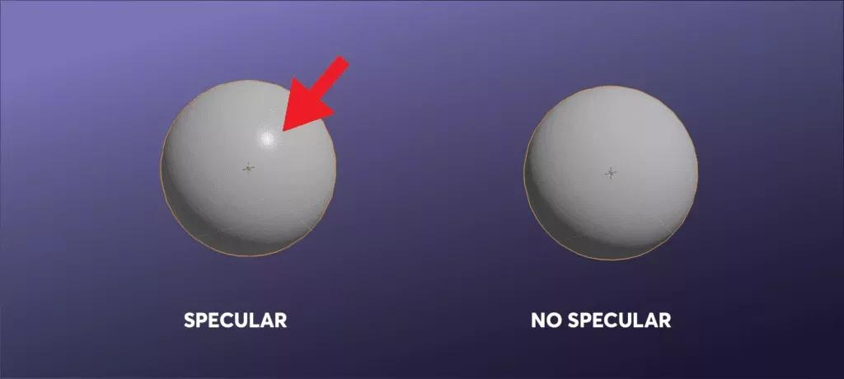
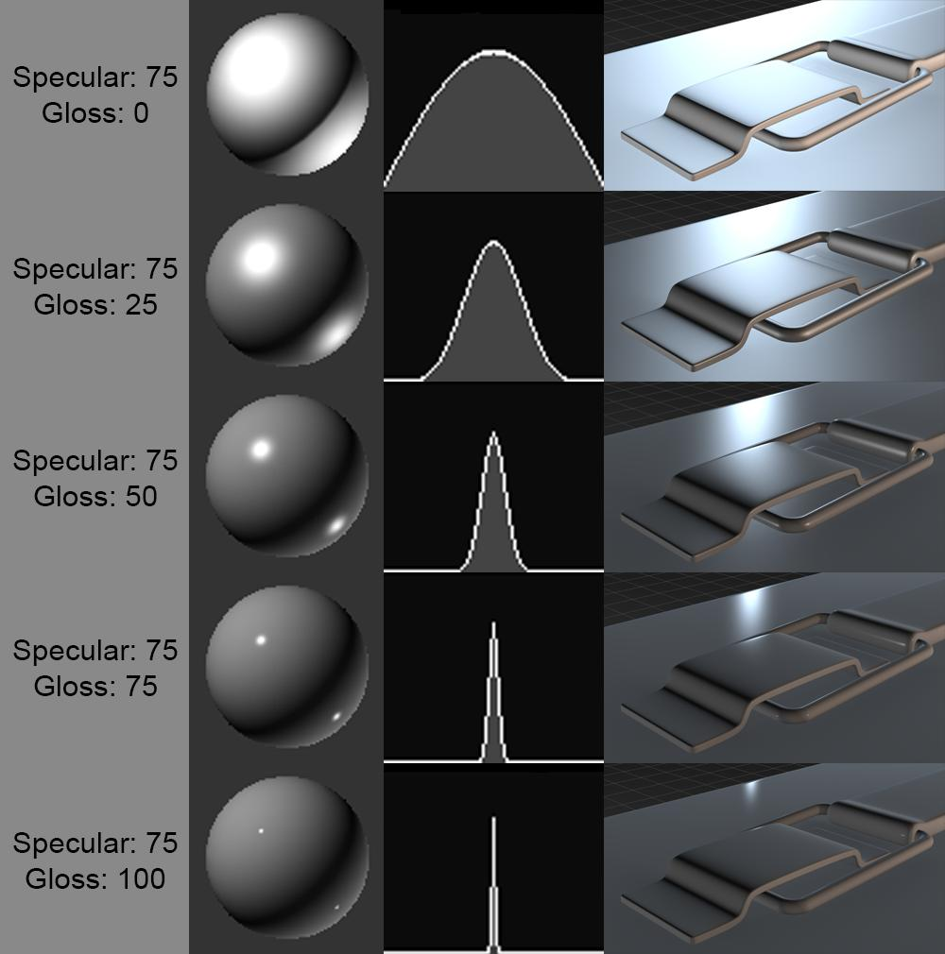

- A black and white (or grayscale) texture map is used
- ⚪ White areas → very shiny (strong reflections)
- ⚫ Black areas → not shiny (no reflections)
- ⚪ Gray areas → medium shine

🧠 Simple example
# Source: AI Source: Provided by: [Data Path: Persons Table -> ID Column: 1, Name_En Column: Motasem Essam] -> From: [ChatGPT] on [5/2/2026]
Think of:
- 🪞 A car body → shiny metal parts (white in specular map)
- 🧽 Rubber tire → dull parts (black in specular map)
So one object can have both shiny and non-shiny areas.

🎮 Where specular textures are used
# Source: AI Source: Provided by: [Data Path: Persons Table -> ID Column: 1, Name_En Column: Motasem Essam] -> From: [ChatGPT] on [5/2/2026]
- 🎮 Video games (metal, glass, water effects)
- 🎬 Movies and CGI (realistic materials)
- 🧑‍🎨 3D modeling and animation
- 🏭 Product visualization (cars, electronics)

⚙️ Key features
# Source: AI Source: Provided by: [Data Path: Persons Table -> ID Column: 1, Name_En Column: Motasem Essam] -> From: [ChatGPT] on [5/2/2026]
- ✨ Controls shininess and reflection strength
- 🎯 Uses grayscale values (black to white)
- 🧩 Works with lighting models (like Phong/Blinn-Phong)
- 💡 Adds realism to materials

🚀 In short:
# Source: AI Source: Provided by: [Data Path: Persons Table -> ID Column: 1, Name_En Column: Motasem Essam] -> From: [ChatGPT] on [5/2/2026]
Specular Texture = a map that controls how shiny different parts of a 3D object are and where highlights appear.

